<<COURT_NAME>>

|  |  |
| --- | --- |
| <<PROVIDER_SUITNAME>>,  a/a/o <<INJUREDPARTY_NAME>>    Plaintiff,  vs.  <<INSURANCECOMPANY_SUITNAME>>  Defendant.  _____________________________________/ | Case No. <<INDEXORAAA_NUMBER>> |

**PLAINTIFF’S MOTION TO COMPEL**

**BETTER RESPONSES TO DISCOVERY OVER OBJECTION**

Plaintiff, <<PROVIDER_SUITNAME>>, by and through the undersigned counsel, hereby files this Motion to Compel Discovery as to Defendant, <<INSURANCECOMPANY_SUITNAME>>, and in support thereof further states:

1. Discovery consisting of interrogatories, request for production and/or request for admissions were propounded upon Defendant, <<INSURANCECOMPANY_SUITNAME>>, on ____.

2. That on ______________, Defendant, filed a response to the foregoing discovery.

3. The response to the foregoing discovery is non-responsive, incomplete, unduly vague or asserts objections that are not relevant for the following items:

------------

------------

------------

4. Plaintiff is entitled to full and complete responses to the foregoing discovery requests as the same are relevant and material to the issues of this case and are not privileged.

WHEREFORE, Plaintiff, <<PROVIDER_SUITNAME>>, requests the Court to enter an Order to compel Defendant, <<INSURANCECOMPANY_SUITNAME>>, to file better responses to the discovery and overrule the Defendant’s objections referenced herein, and grant such other further relief that is just and appropriate under the circumstances.

**CERTIFICATE OF SERVICE**

I HEREBY CERTIFY that on February 19, 2022, a true and correct copy of the foregoing was filed and served on the Defendant through Florida Courts E-Filing Portal.

**Florida Insurance Law Group, LLC**

8724 Sunset Drive, #260, Miami, FL 33173

Tel. (305) 906-4262

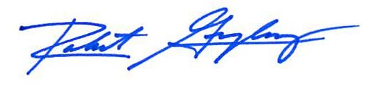

Robert F. Gonzalez, Esq.

Fla. Bar No. 68865

Pleadings@flinslaw.com